Milen Kozhuharov
.NET / MEAN / JAVA WEB DEVELOPER








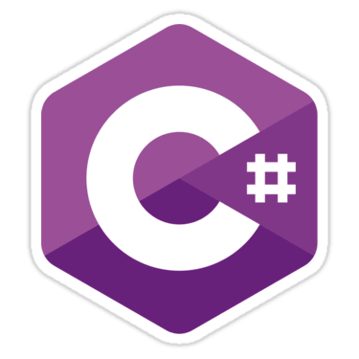


Personal Profile

  With love for computers and tech, my passion grew from a hobby to QA and naturally - career choice as a developer. Persistent and energetic, I always learn from a good challenge and constantly self-improve.
  Rishon Letsiyon, 058-4442485
  milen.kozhuharov@gmail.com
  Israeli ID & EU passport holder milenski.azurewebsites.net
  github.com/milensk1
 |     
  Job Experience
  Jan 2013 - Jan 2017
  QA ENGINEER , PROJECT MANAGER & BUSINESS ANALYST
  TSD Services Ltd.
  - Managed projects for US-based e-discovery leader - kCura.
  - Established and led an agile team of 5 people covering the front, backend and testing activities for the product.
  - Delivered with quality and on time.
  - Helped my company to become preferred software vendor in kCura's ecosystem entering "eDisclosure systems buyer guide" for 2016.
  - Tested software for a major car loan company - Santander USA.
  Mar 2011 - Oct 2012
  BUSINESS ANALYST
  CSMS Ltd. (a ‘Playtech’ company)
  - Provided complexed statistics, data analysis, and reports based on Excel.
  
  - Supported upper management in their decision-making process for UK's largest interactive TV gaming company - NetPlay TV.
  Technologies
  OS
  MS Windows / Server, Ubuntu,
  macOS
  VIRTUALIZATION AND CLOUD
  VMWare, Hyper-V, Azure
  LIFECYCLE MANAGEMENT
  Jira, Rally, Trac, HP ALM
  WEB / DESKTOP DEVELOPMENT
  C#, SQL & Entity Framework,
  ASP.NET MVC / Core,
  JavaScript, MEAN Stack
  HTML5, CSS,
  Java,
  WPF / UWP & XAML,
  WordPress
 | 
  …
  Mar 2008 - Nov 2010
  QA ENGINEER
  Callwave Ltd.
  - Tested the desktop version of emerging collaboration platform that's now successful major player in HD audio and video conferencing - Fuze
  Sep 2004 - May 2006
  MARKETING SPECIALIST
  CMSG Ltd.
  - Advertised IPO in Europe and Canada for leading American manufacturer of performance car components
  Certificates
  ISTQB Foundation level (QA Testing)
  Strengths
  Endless positivity in harsh times
  Working in call center 'boiler room' taught me that a smile is the ultimate weapon!
  Focus
  Keeping an eye on the target is key

Education

  Sep 1999 - June 2004
  SPECIALIST IN ELECTRONIC COMPUTING TECHNICS
  SVHS “John Atanasoff” High school
  Oct 2004 - June 2008
  BACHELOR ”ECONOMY OF COMMUNICATIONS”
  University of National and World Economy - Sofia
  Oct 2015 – Aug 2017
  FULL STACK WEB DEVELOPER
  “Softuni” University & self-coaching

  Languages
  BULGARIAN | Native
  ENGLISH | Proficient
  HEBREW | Studying independently
  Personal
  PASSIONS
  Economics and politics, Sci-fi, Drums, Apple hardware
  BOOKS & MOVIES
  2001: A Space Odyssey, Ender's game, Geopolitics magazine, Avalon, Dune, GoT
  …
  Thinking outside the box
  If life gives you lemons don't make lemonade! Return them instead and demand a meeting with the manager.
  0 sick leaves in my entire career (!)
  Proactive team player

